How to debug using Chrome DevTools

1. Press Command+Option+I to open Dev Tools
2. 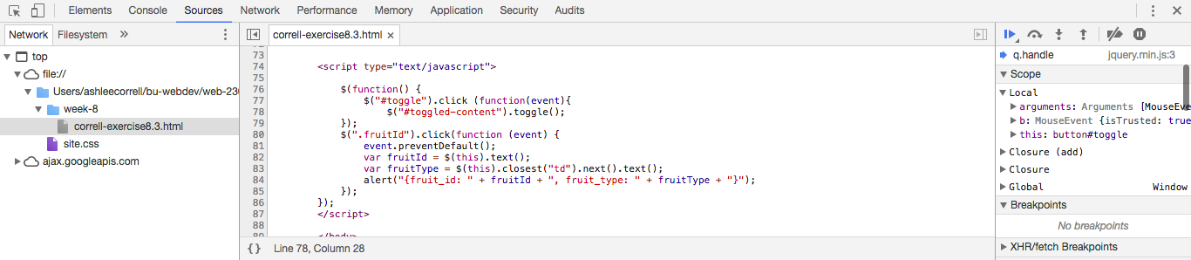Select the file you want to edit from the file pane.
3. The code for the file will show up in the code editor pane.



1. To set a break point, simply click the line of code you want to pause at and it will highlight blue. To deselect, click the line number again and the highlight will disappear. You can also clear all the break points by clicking: 
2. 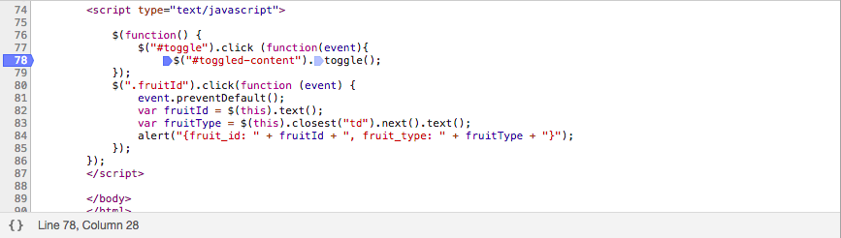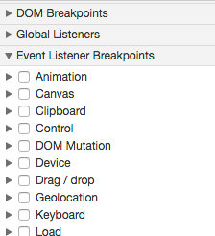You can also set Event Listener Break Points which pause the code when a certain event happens. You do this by selecting the event in the debugging pane.
3. To execute each line of code line by line, use the buttons at the top of the debugging panel: 
   1.  allows you to skip to the next function.
   2. allows you to skip through a function line by line
   3. allows you to step out of a function
4. 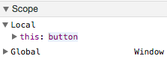You can see which variables are defined in the code you are examining by looking at the scope pane.
5. The Watch Expressions pane lets you see how the value of variables changes overtime.
6. You can target HTML elements by clicking the elements tab.

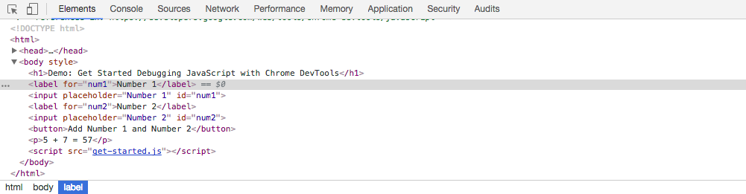

1. To edit styles, click the styles tab to the left and add or change CSS styles

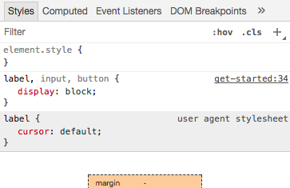

1. You can also set break points using the DOM by right clicking the element and choosing how you want to set the break point.

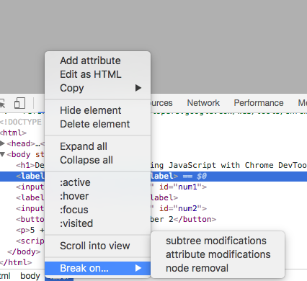

1. To add CSS to live HTML elements, click + to create a new rule, and type the code in the editor below.

